# _LITfinalLOGO

# SUMMER EXAMINATIONS 2015

**Monday, 11th May 2015, 14.30 p.m. – 17.00 p.m.**

**KSDEM\_8\_Y2**

**Programme:** Bachelor of Science (Honours) in Software Development

**Stage:** Two

**Module:** Mathematics for Computing

**Time Allowed:** 2½ Hours

**Instructions:**

**1.** Answer **FOUR** of the following **FIVE** questions.

**2.** All questions are equally weighted.

**Additional Attachments or Exam Material to accompany this paper:**

### A. None

**Internal Examiner(s): External Examiners(s):**

Dr Oliver Hyde Mr Brian Gillespie

**Q. 1**

**(a)**

In a room there are more than 50 people with ages between 1 and 100. Use the Pigeonhole Principle to show that either two people have the same age or that there are two people who were born within one year of each other.

**(5 marks)**

**(b)**

*School master* is an anagram of the phrase *the classroom*. How many anagrams in total can be made from the letters in the phrase *the classroom*?

**(4 marks)**

**(c)**

Consider the binomial expansion of (2*x* – *y*)8.

1. How many terms are there in the expansion?

**(1 mark)**

1. Is there a single middle term or are there two middle terms? Find the middle term(s) and explain.

**(5 marks)**

**(d)**

Beams are designed as a support for various bridges. The beams are constructed using rods. The length of the beam is determined by the number of rods used to construct the bottom of the beam. The following diagram shows a beam of length 4.

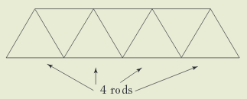

Let *Rn* denote the number of rods needed to make a beam of length *n*.

1. Find the value of each of the first four terms in the sequence, *R1* to *R4*.

**(4 marks)**

1. Find a recursion formula for *Rn*, for all *n* ≥ 2. State the initial condition (*n* = 1) required for this recursion formula.

**(6 marks)**

**(Total 25 Marks)**

**Q. 2**

**(a)**

Use the Euclidean Algorithm to find the greatest common divisor of each of the following pair of integers.

1. 252 and 660.

**(3 marks)**

1. 2,415 and 3,289.

**(3 marks)**

**(b)**

The Division Algorithm states that for every two integers *a* and *b* there exist unique integers *q* and *r* such that *a* = *bq* + *r* where 0 ≤ *r* < |*b*|.Find the quotient *q* and the remainder *r* as defined in the Division Algorithm, in each of the following cases.

1. *a* = 589,621; *b* = 7,893.

**(2 marks)**

1. *a* = –5,286; *b* = –19.

**(3 marks)**

**(c)**

Find the prime decomposition of each of the following numbers.

1. 210 – 1.

**(3 marks)**

1. 503.

**(3 marks)**

**(d)**

The calculation of an ISBN-13 check digit begins with the first 12 digits of the thirteen-digit ISBN (thus excluding the check digit itself). Each digit, from left to right, is alternately multiplied by 1 or 3 (i.e.,1st + 3rd + 5th + … digits are multiplied by 1 and 2nd + 4th + 6th + .. digits are multiplied by 3), then those products are summed modulo 10 to give a value (**sum**) ranging from 0 to 9.

To get the check digit, subtract **sum** from 10 leaving a result from 1 to 10. A zero (0) replaces a ten (10), so, in all cases, a single check digit results.

Find the digit ***D*** so that each of the following ISBN-13 numbers are valid:

1. “It’s All in the Head” by Majella O’Donnell 978147113894***D***

**(4 marks)**

1. “The Test” by Brian O’Driscoll 978184***D***882915

**(4 marks)**

**(Total 25 Marks)**

**Q. 3**

**(a)**

You’re in the mob—but you’re a double-crosser. So you write a book that reveals all the mob’s secrets: who murdered whom, where the hideouts are, etc. Your first idea is to publish the book with your name on the cover, so you’ll be hailed as a hero who brought down the mob. But after thinking it through, you realize that’s not the best idea — you don’t want your feet in cement. So you’ll publish it anonymously. But then you’ll never get credit for what you did! Later on, after the mob leaders have been arrested (thanks to your efforts) and it’s safe, you could tell people you wrote the book, but there’d be no reason for them to believe you. Is there a way to publish the book so that (1) it’s anonymous now, but (2) later on you can prove that no one but you could have written it? Explain your answer.

**(6 marks)**

**(b)**

Explain, with the aid of a diagram, the concept of public key cryptography (asymmetric key cryptography). Include two advantages and two disadvantages of the technique as part of your explanation.

**(9 marks)**

**(c)**

As a member of the Garda Special Branch C3 section (the Irish Secret Service), you have identified a spy and want to send a message with the spy’s initials “EK” (encoded using the RSA algorithm) to your superior officer. Suppose *n* = *p*×*q* = 47×59 = 2,773 and the encryption key *e* = 3.

1. Convert the message to plaintext *P* and then to ciphertext *C*.

**(4 marks)**

1. Your superior officer receives the ciphertext *C* and must decipher it. Find the value of the decryption key *d* and explain how the ciphertext *C* is decrypted to plaintext *P*.

**(6 marks)**

**(Total 25 Marks)**

**Q. 4**

**(a)**

Consider a variant on the Bridges of Königsberg puzzle with red and blue castles, a church, and an inn. The northern bank of the river is occupied by the castle of the Blue Prince; the southern by that of the Red Prince. The east bank is home to the Bishop’s church; and on the small island in the centre is an inn.

[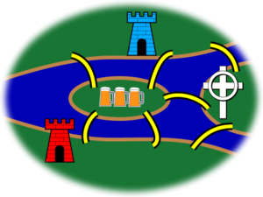](http://en.wikipedia.org/wiki/File:7_bridgesID.png)

It being customary among the townsfolk, after some hours in the inn, to attempt to “walk the bridges”, many have returned for more refreshment claiming success. However, none have been able to repeat the feat by the light of day.

1. The Blue Prince, having analyzed the town's bridge system by means of graph theory, concludes that the bridges cannot be walked. He thinks up a stealthy plan to build an eighth bridge so that he can begin in the evening at his castle, walk the bridges, and end at the inn to brag of his victory. Of course, he wants the Red Prince to be unable to duplicate the feat from the Red Castle. *Where does the Blue Prince build the eighth bridge?*

**(5 marks)**

1. The Red Prince, infuriated by his brother's solution to the problem, wants to build a ninth bridge, enabling *him* to begin at his castle, walk the bridges, and end at the inn to rub dirt in his brother's face. As an extra bit of revenge, his brother should then no longer be able to walk the bridges starting at his castle and ending at the inn as before. *Where does the Red Prince build the ninth bridge?*

**(5 marks)**

1. The Bishop has watched this frantic bridge-building with dismay. It upsets the town's social balance and, worse, contributes to excessive drunkenness. He wants to build a tenth bridge that allows *all* the inhabitants to walk the bridges and return to their own beds. *Where does the Bishop build the tenth bridge?*

**(6 marks)**

**(b)**

Use Kruskal’s algorithm to find a spanning tree of minimum total weight for the following graph. State the total weight of your tree and list the steps taken in applying the algorithm.

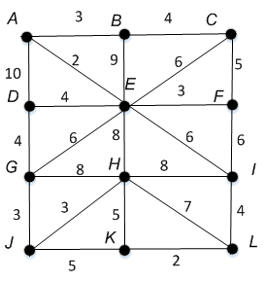

**(9 marks)**

**(Total 25 Marks)**

**Q. 5**

**(a)**

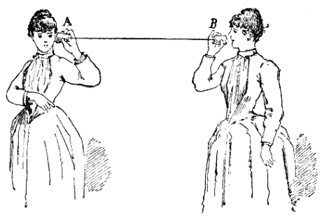

Is the following argument valid? Explain your answer.

A tin can telephone[[1]](#footnote-1) is better than nothing.

Nothing is better than a smartphone.

\_\_\_\_\_\_\_\_\_\_\_\_\_\_\_\_\_\_\_\_\_\_\_\_\_\_\_\_\_\_\_\_\_\_\_\_\_\_\_\_\_\_\_

→ A tin can telephone is better than a smartphone.

**(5 marks)**

**(b)**

Write the following argument in symbolic form, then use a method of your choice to prove that the argument is invalid.

*If I have a good round of golf then the wind is calm or the weather is dry. The wind is calm and the weather is dry. Therefore, I have a good round of golf.*

**(10 marks)**

**(c)**

Give meaningful English translations of the following well-formed formulas, where

*D(x)* is “*x* is a day”.

*S(x)* is “*x* is sunny”.

*R(x)* is “*x* is rainy”.

1. ∃*x* **(***D(x)* ∧ ~*R(x*)**)**

**(2 marks)**

1. ∀*x* **(***D(x)* ∧ *S(x*) → ~*R(x*)**)**

**(3 marks)**

1. ~[∃*x* **(***D(x)* ∧ *S(x*) ∧ *R(x)***)**]

**(3 marks)**

1. ∀*x* **(***D(x)* → ~*S(x*)**)**

**(2 marks)**

**(Total 25 Marks)**

1. A *tin can telephone* is an old-fashioned speech transmission device, consisting of two tin cans connected by a taut piece of string or wire (see illustration at top of page). [↑](#footnote-ref-1)